ASSIGNMENT-1

FUNDAMENTAL OF DATA SCIENCE



Submitted By: Karuna Mishra
Student Id: 24071179
14th April , 2025

Part-1
Q1. The perimeter of a rectangle with length 9 & width 6

Code:

''' This program shows the Perimeter of rectangle whose length 9, width 6'''
perimeter=2*(9+6)
print(perimeter)

Output:
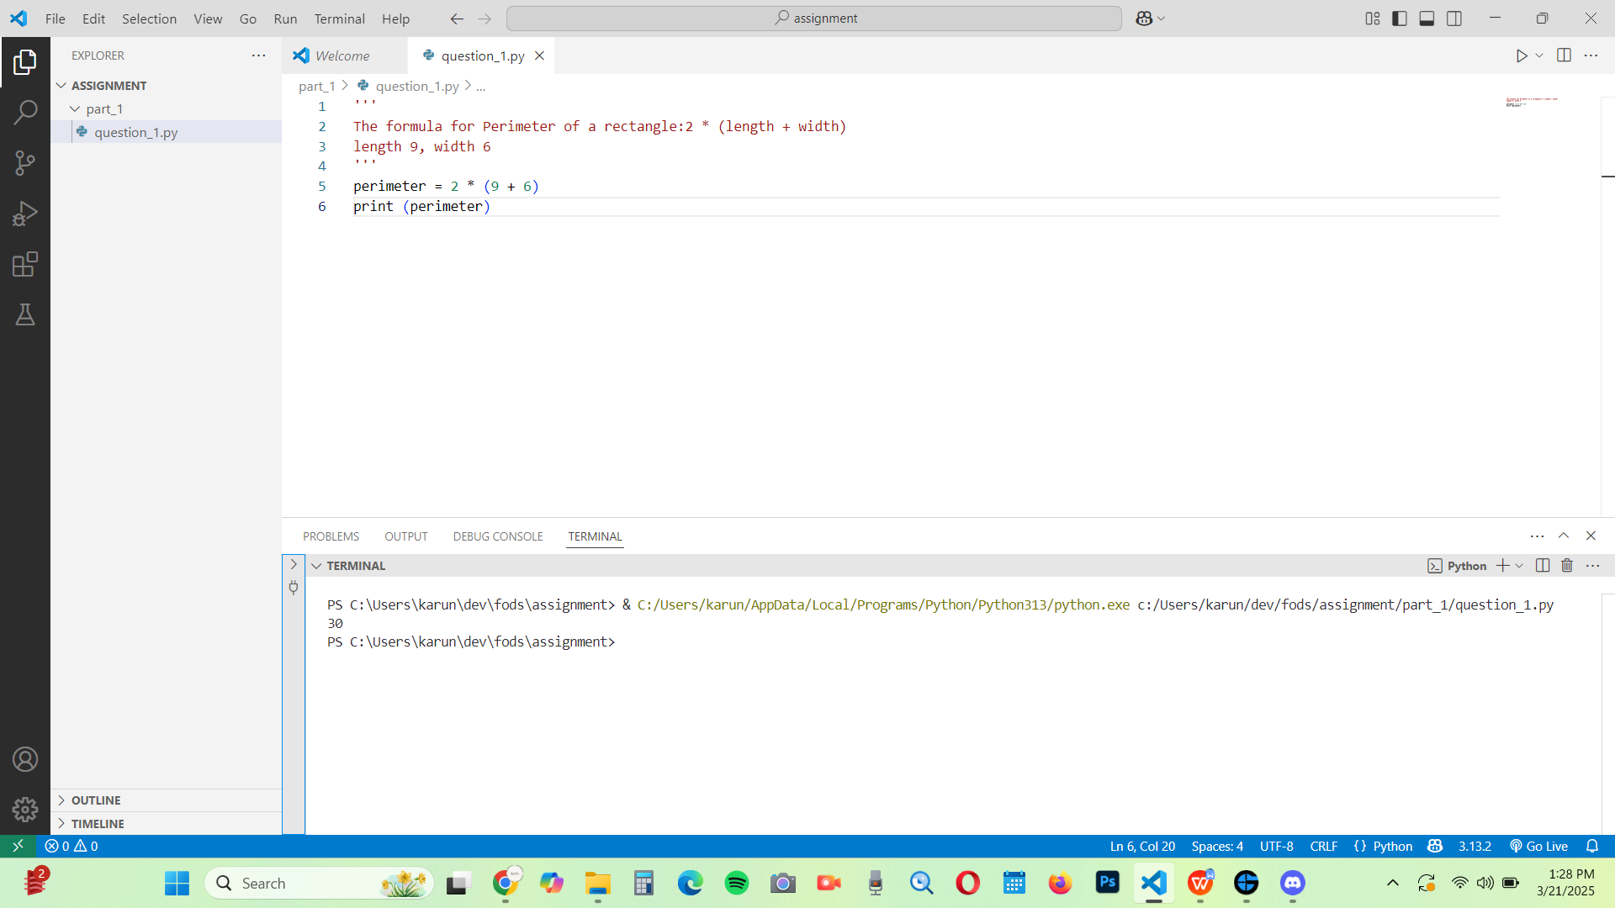

Q2. Python is great, it’s wild!

Code:
'''This program shows the print'''
print ("Python is great, it's wild! ")

Output:

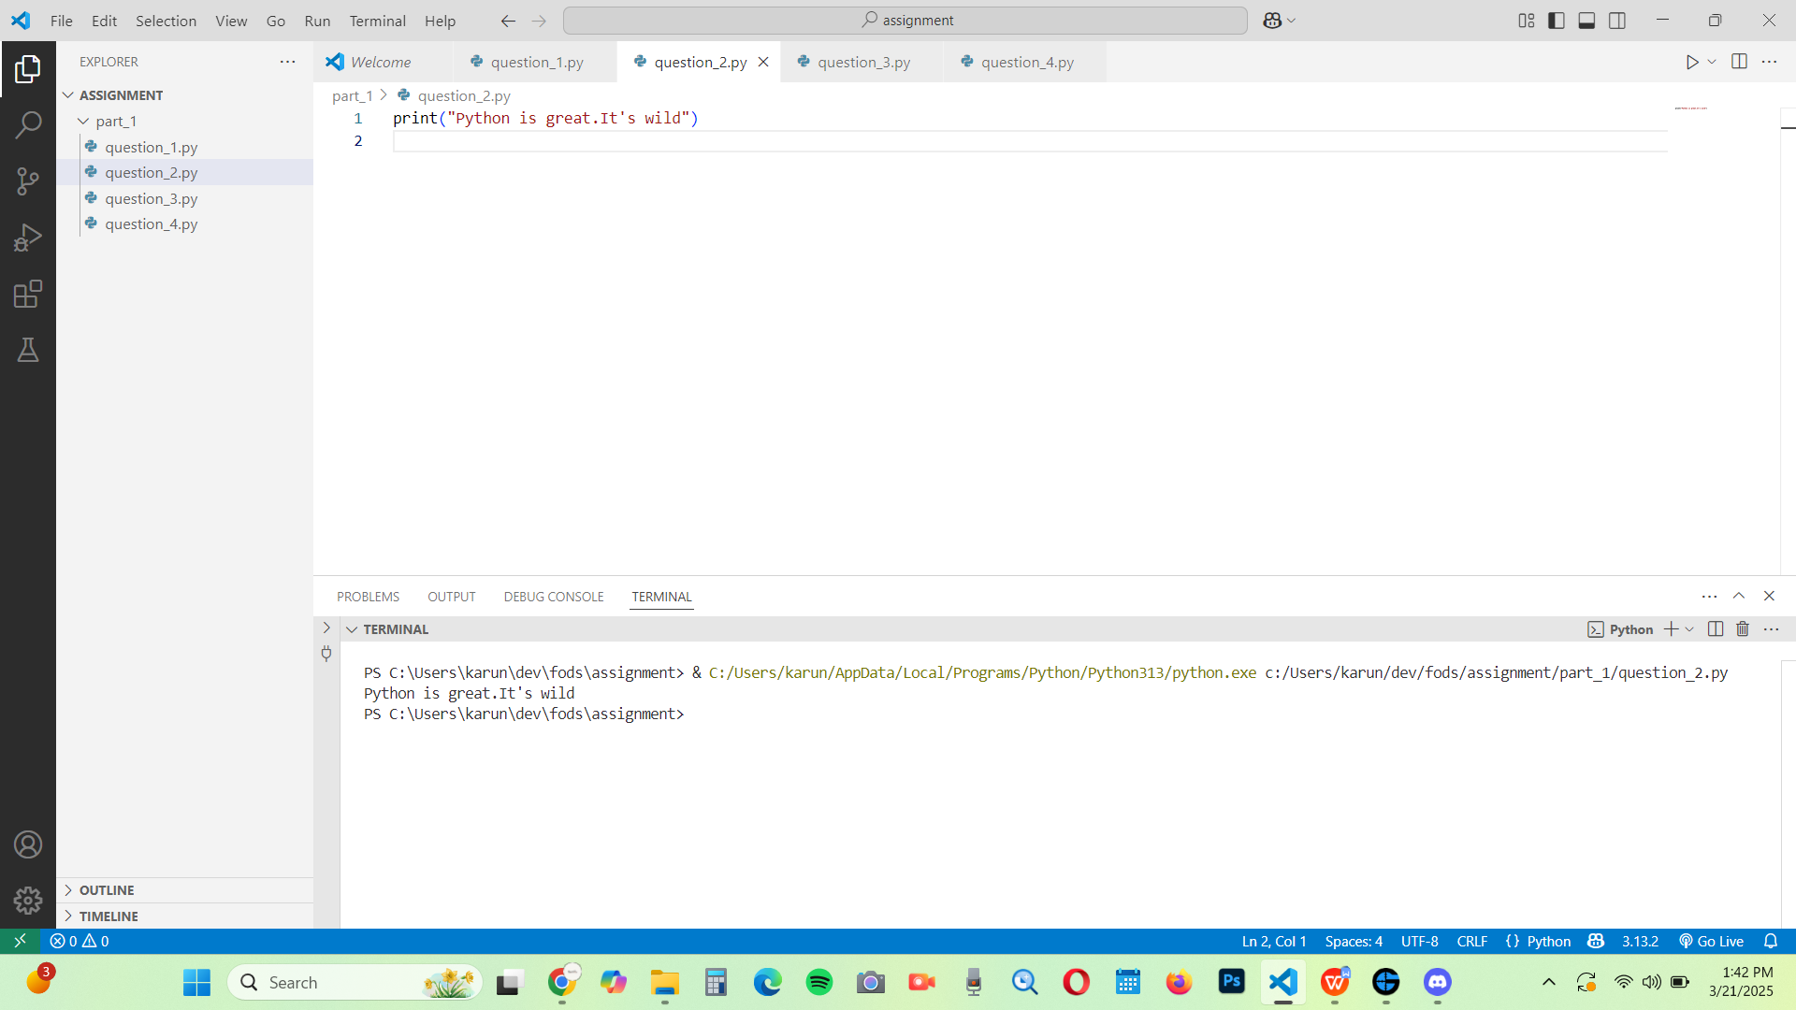

Q3. 2 to the 10thpower.

Code:

'''This program prints the value of'''
Print ("2 to the 10thpower")

Output:
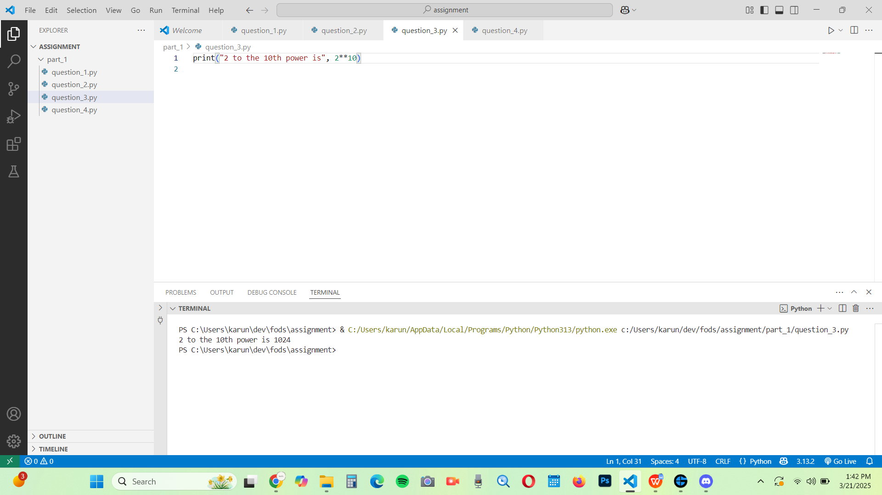

Q4. 7factorial minus 5factorial.

Code:
'''This program shows the factorial'''
import math
print "7! - 5! = ", math. factorial (7)-math. Factorial (5))

Output:

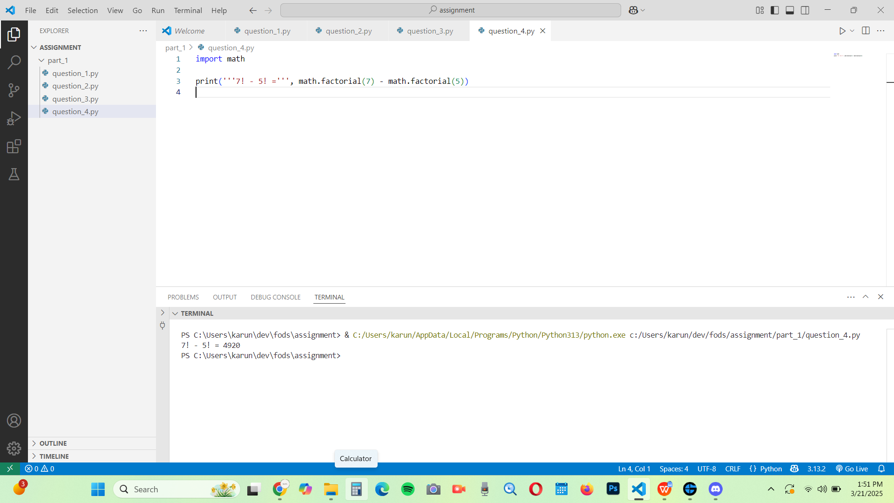

Q5. Your forename multiplied by 5.

Code:
'''This program shows the forename multiplied'''
Print (‘’’Karuna’’’ *5)

Output:

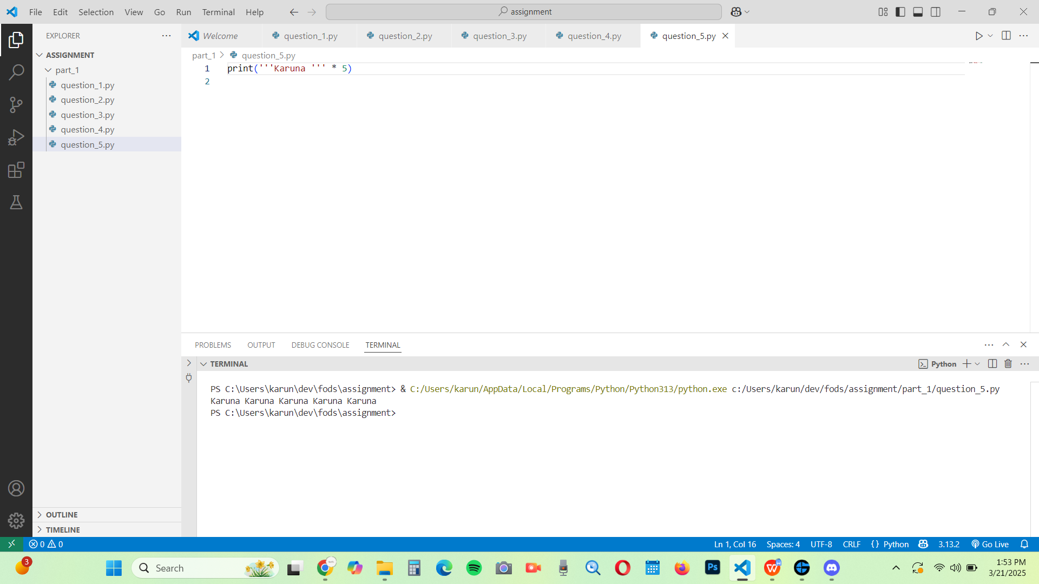

Q6. Your name left justified 15 spaces.

Code:
'''This shows the name left justified'''
Print ("’Karuna"’ .l just (15))

Output:

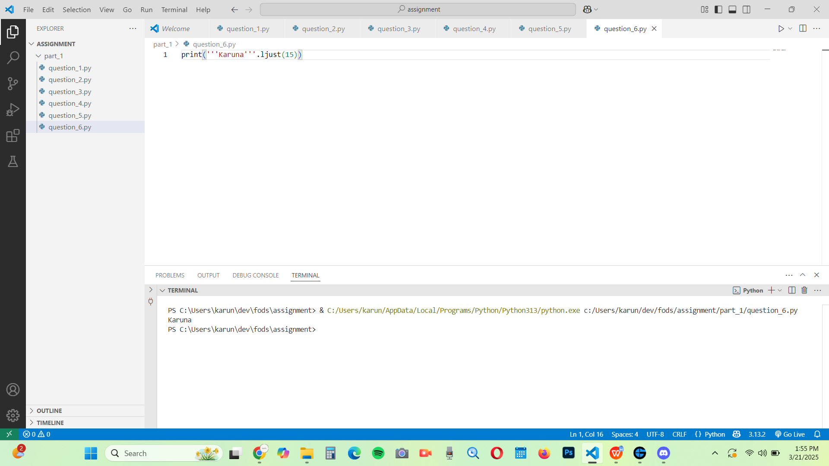

Q7. PI to 5 decimal places.

Code:
'''This program show the PI to decimal places'''
import math
print (math. pi)
print(round(math.pi,5))

Output:

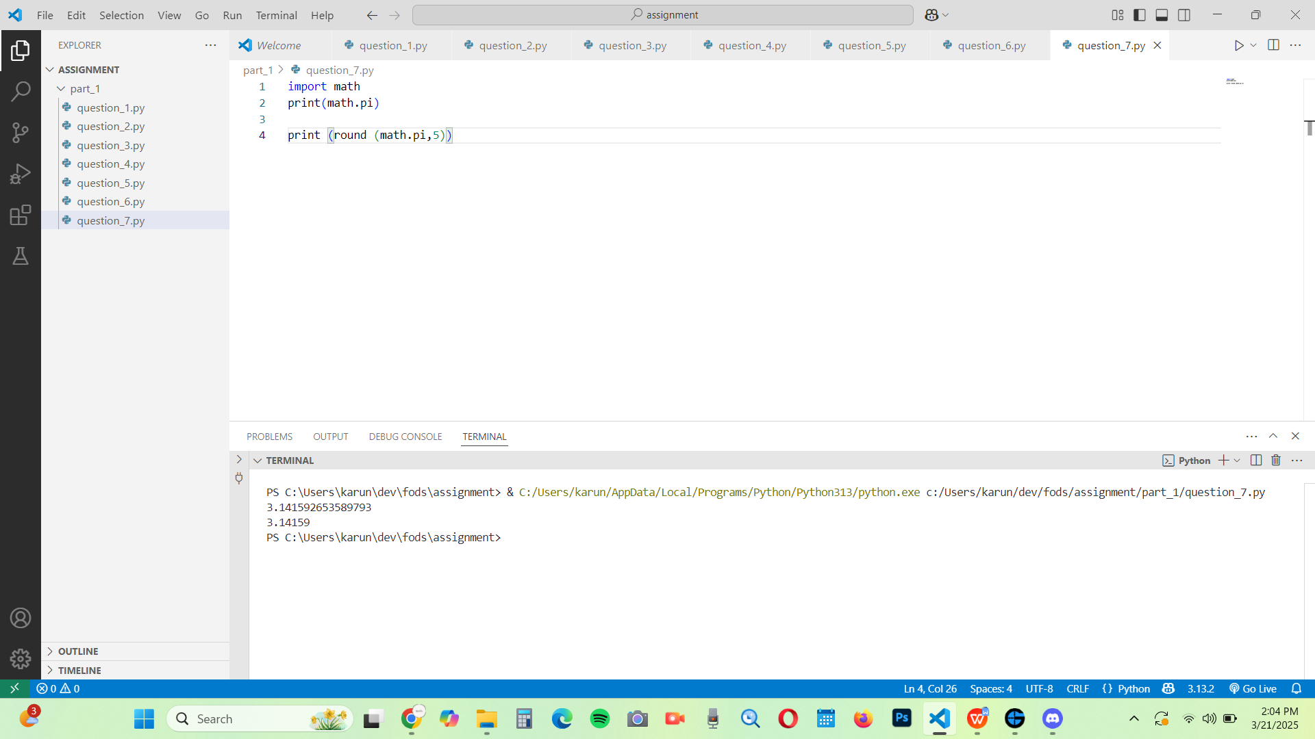

Q8. 200 modulus 12.

Code:
'''This program prints the modulus'''
print (200 % 12)

Output:
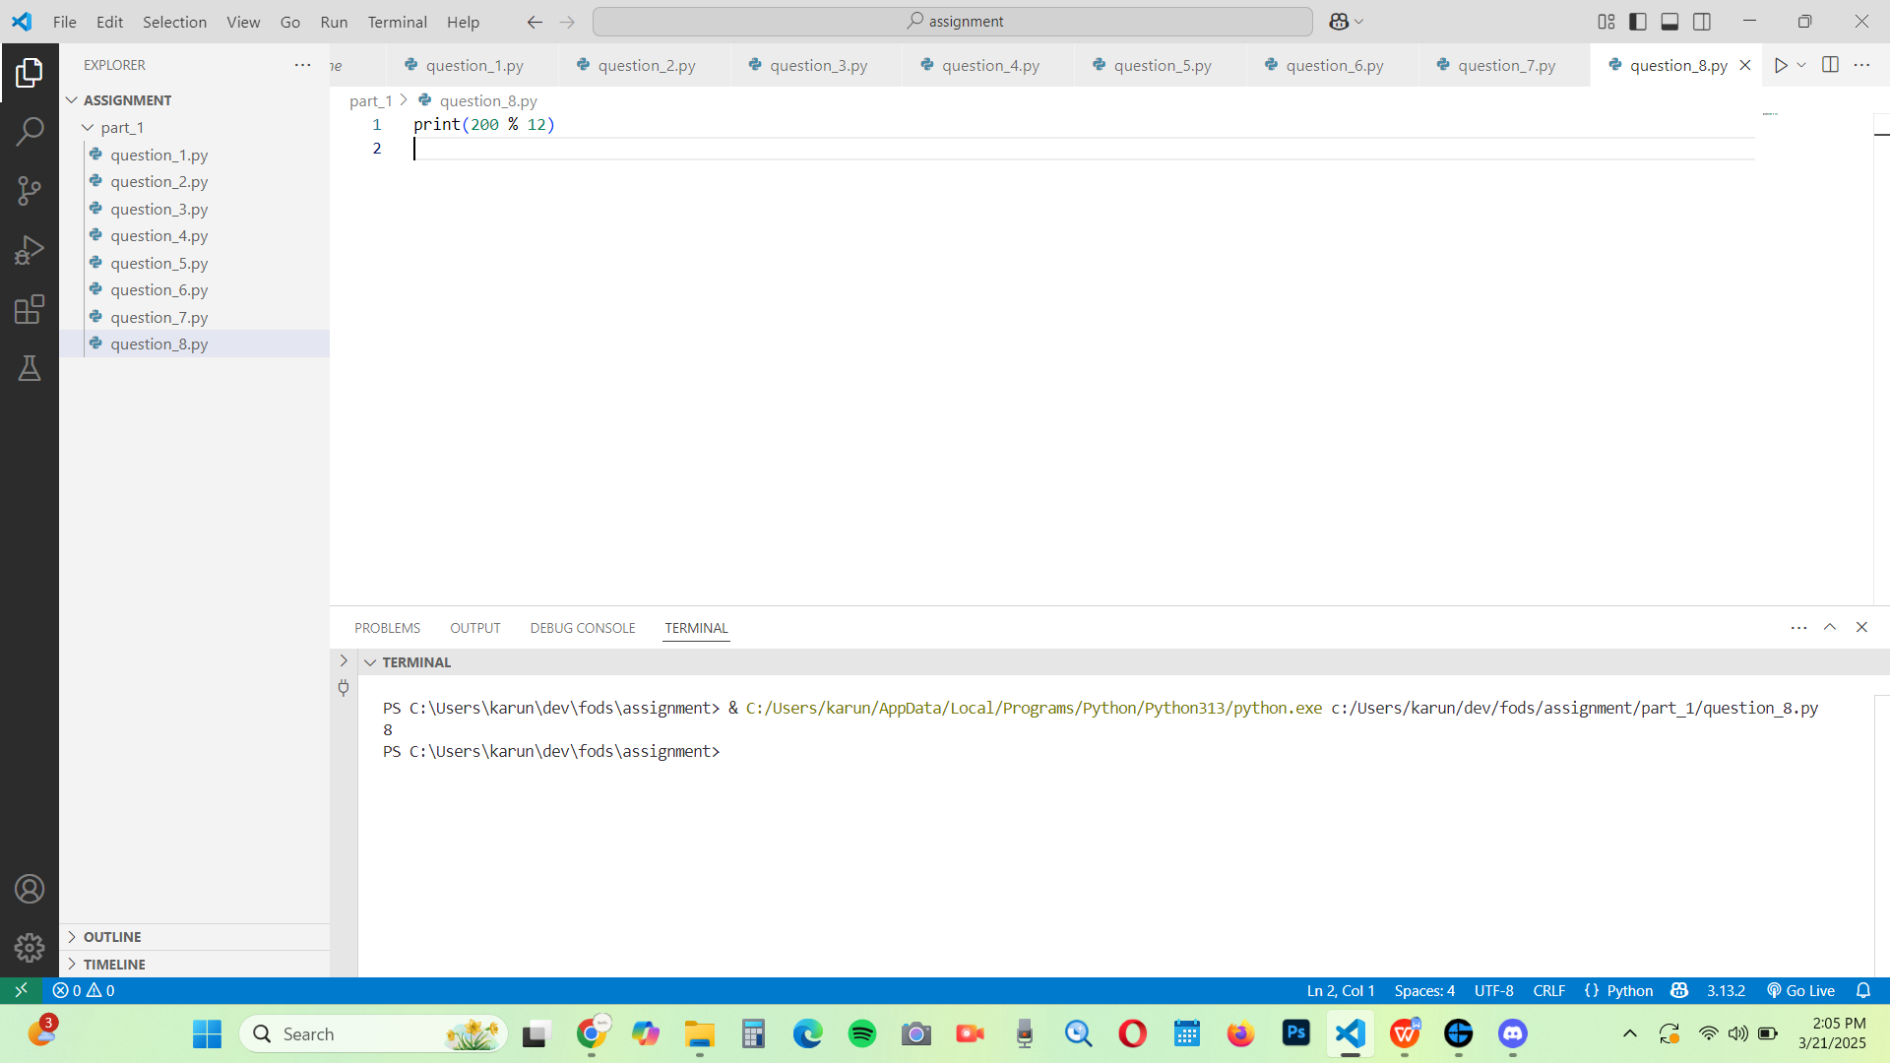

Q9. 7.2 as an integer value.
Code:
'''This program show the integer valie'''
print (int (7.2))

Output:
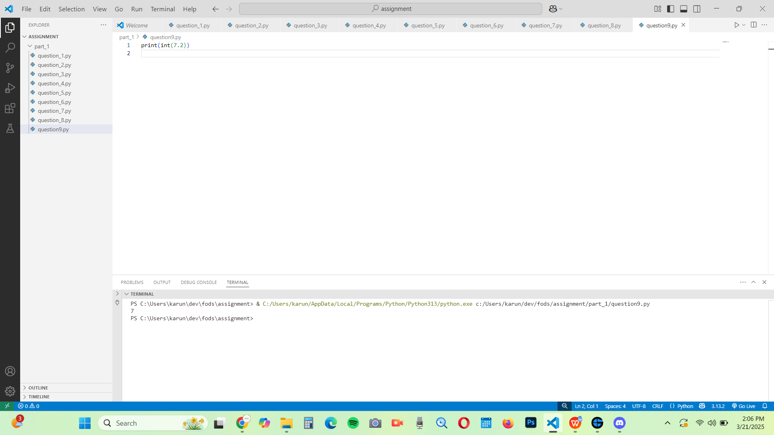

Q10. The Unicode encoding for your name.

Code:
'''This program show the unicode encoding '''
name="Mansa"
Unicode _ values = [ ord (char)for char in name]
print (Unicode _ values)

Output:

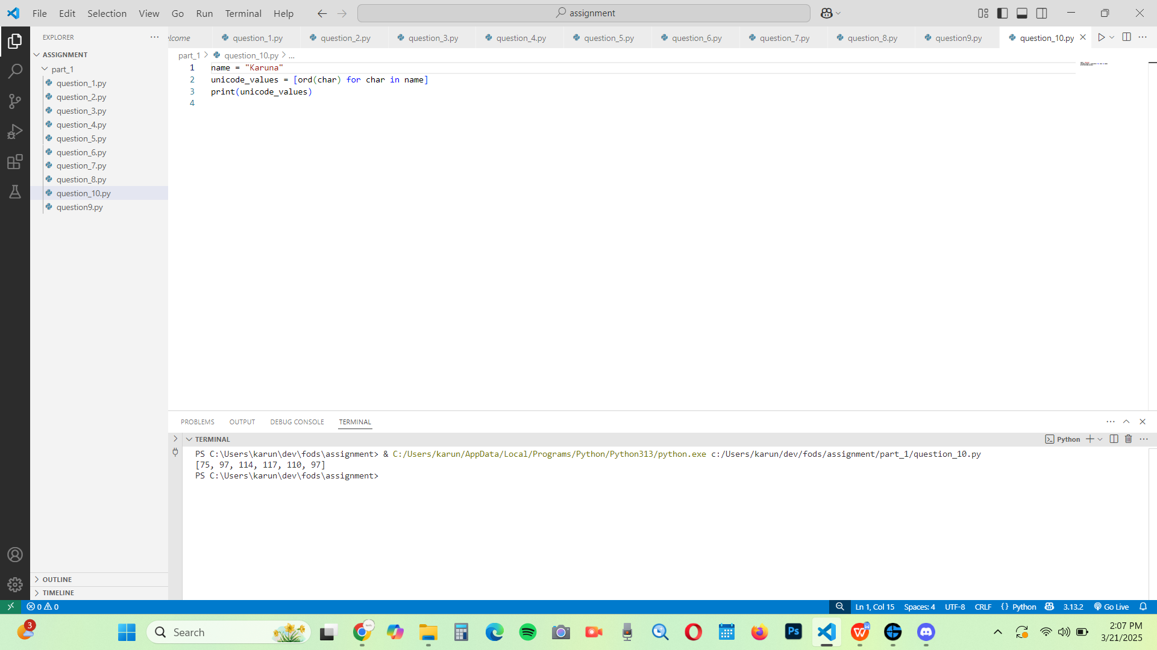

Part-2
Q1. Write a program to take a number input from the user and display whether the number is even or odd.
Code:
'''This program shows whether the number input is odd or even '''
# Take input from the user
num = int (input ("Enter a number: "))
# Check if the number is even or odd
if num % 2 == 0:
print(f"{num} is Even")
else:
print(f"{num} is Odd")
Output:
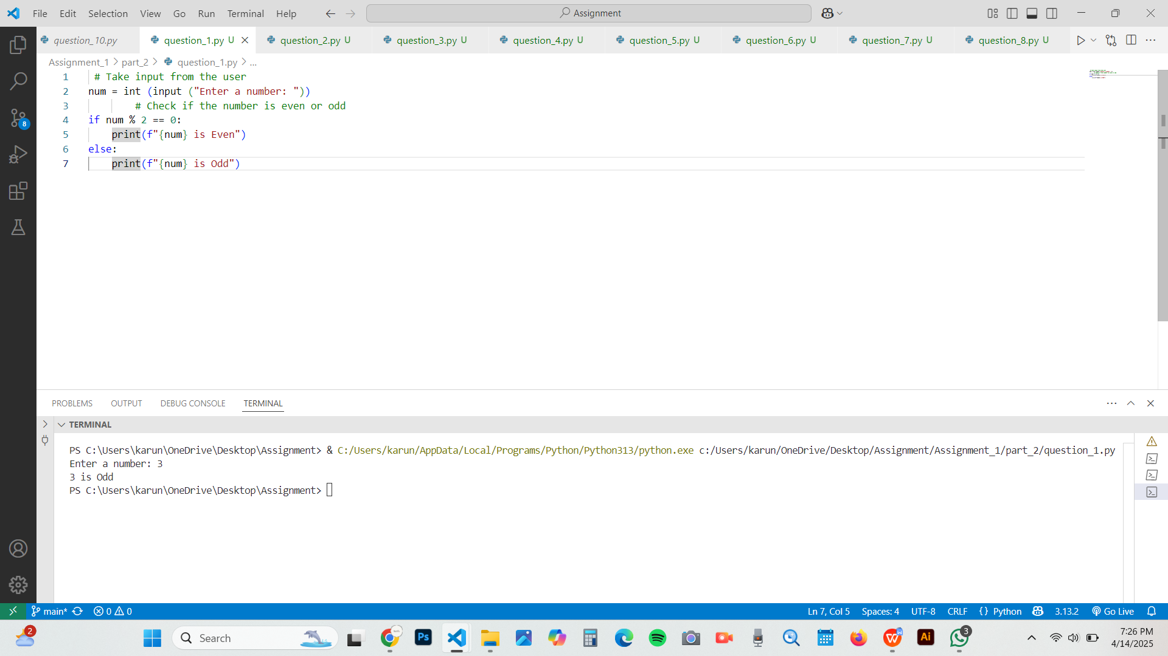

Q2. Write a program that prompts the user for two integer values and displays the results of the first number divided by the second, with exactly two decimal places displayed.
Code:
'''This program shows how to take two integer inputs from the user and display the result of the first number divided by the second'''
#Take two integer inputs from the user
num1=int (input ("Enter the first interger:"))
num2=int (input ("Enter the second interger"))
# Check if the divisor is not zero to avoid division error
if num2==0:
print ("Error! Division by zero is not allowed.")
else:
result=num1/num2
print (f "result: {result:.2f} ") #Display result with 2 decimal places
Output:

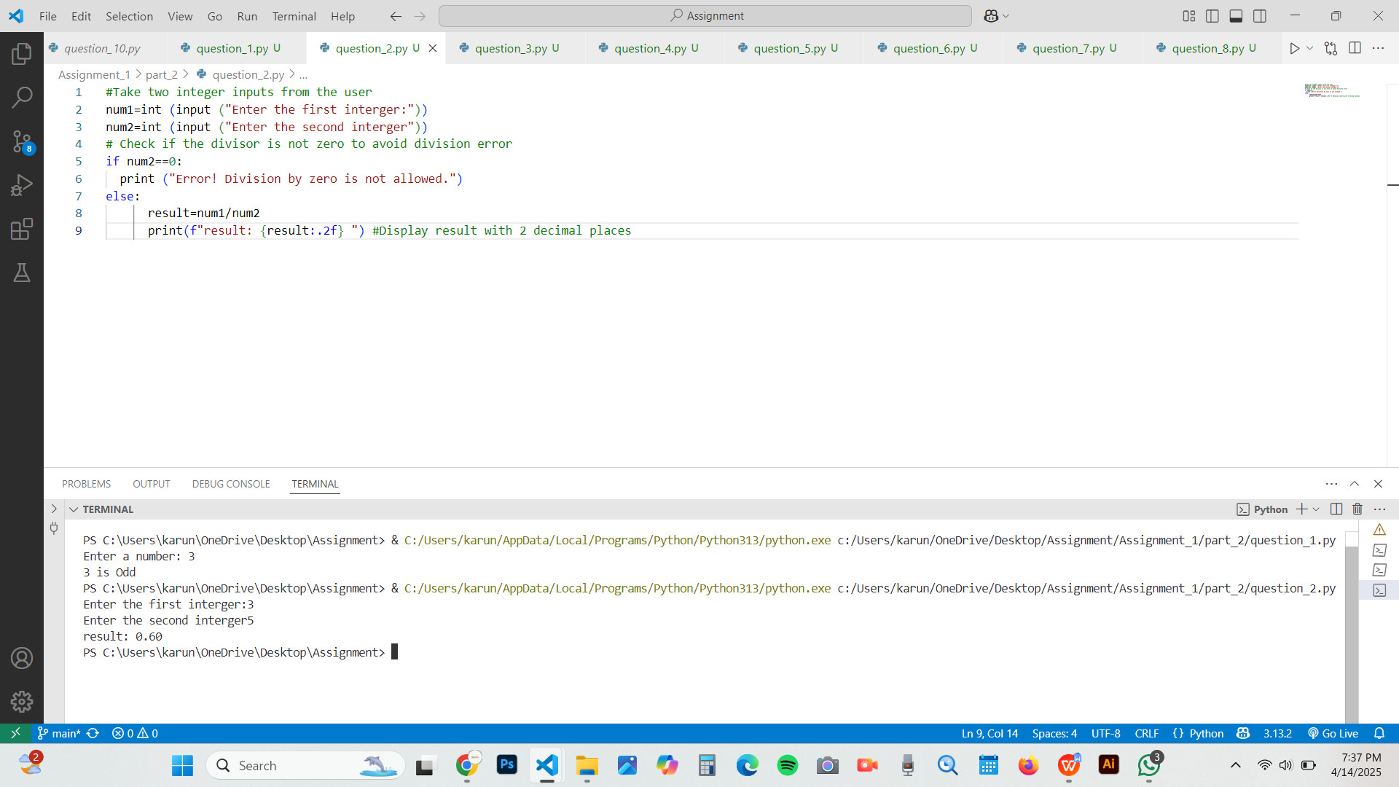

Q3. Write a program that will convert Celsius value to Fahrenheit.
Code:
'''This program converts a Celsius temperature to Fahrenheit.'''
#Enter a temperature in Celsius
celsius =float (input ("Enter temperature in Celsius:"))
fahrenheit= (celsius * 9/5) + 32
print(f"{celsius:.2f} °C is equal to {fahrenheit:.2f} °F")
Output:

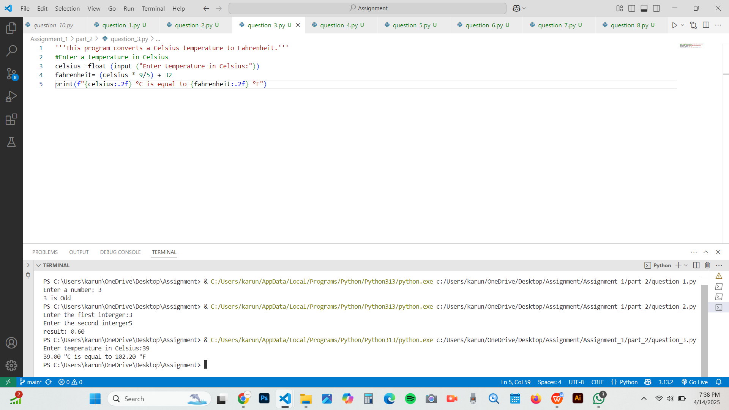

Q4. Write a program to find the Euclidean distance between two coordinates. Take both the coordinates from the user as input.
Code:
'''This program calculates the Euclidean distance between two points'''
import math
#Taking input from the user for the first point (x1, x2)
x1=float (input ("Enter x-coordinate of the first point:"))
y1=float (input ("Enter y-coordinates of the first point"))
#Taking input from the user for the second point (x2, y2)
x2=float (input ("Enter x-coordinates of the second point:"))
y2=float (input ("Enter y-coordinates of the second point:"))
distance=math. sqrt ((x2-x1) ** 2+(y2-y1) ** 2)
print (f "The Euclidean distance between({x1}, {y1} and) and ({x2}, {y2}) is:{distance:.2f}")
Output:

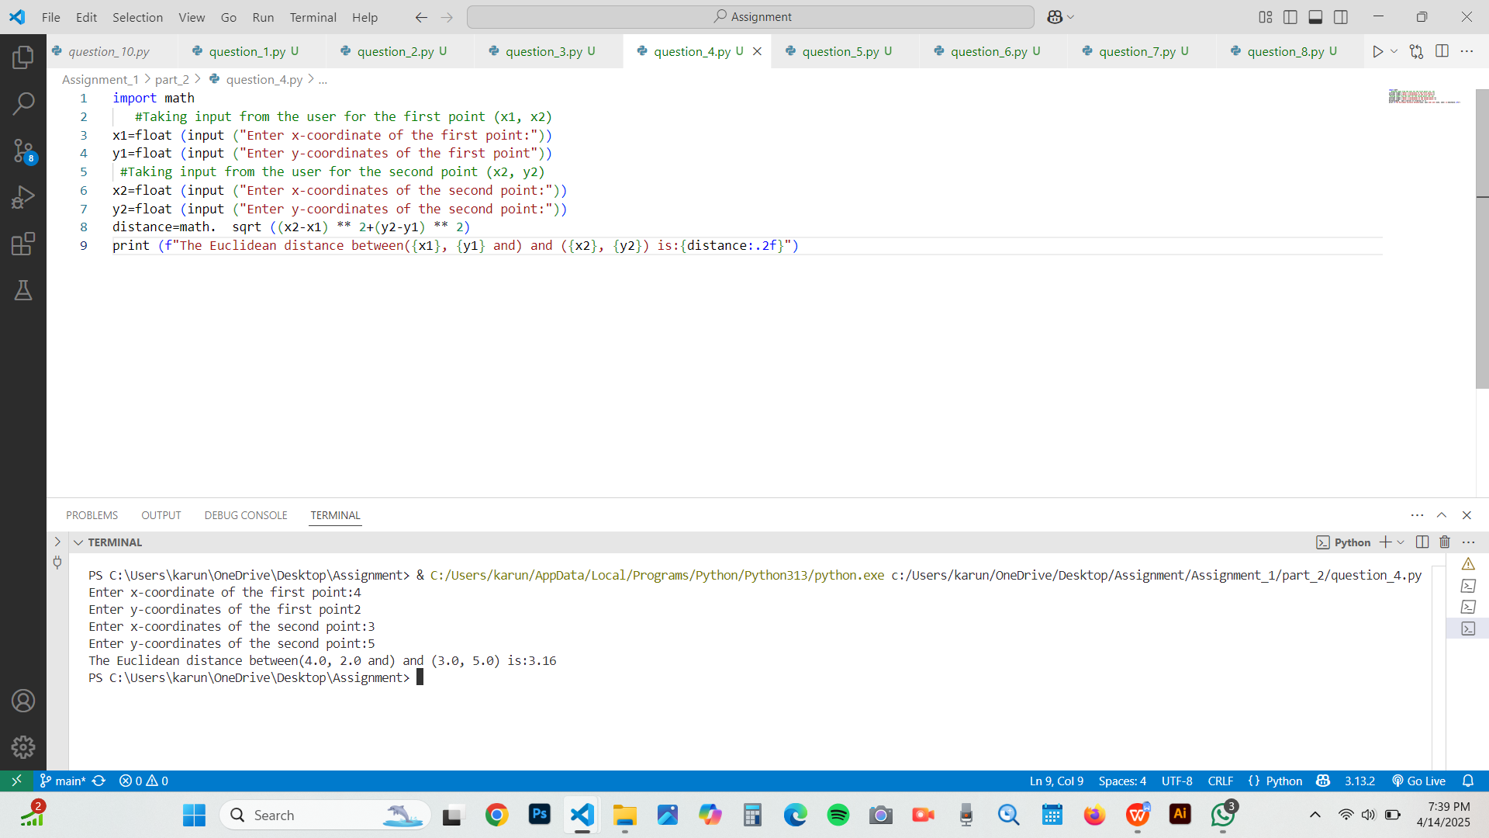

Q5. Write a program to find the simple interest when the value of principle, rate of interest and time period is provided by the user.
Code:
'''This program shows the calculation of simple interest'''
principal=float (input ("Enter the principle amount:"))
rate=float (input ("Enter the rate of interest(in%):"))
time=float (input ("Enter the time period (in years):"))
simple_ interest=(principal*rate*time)/100
print (f "The Simple Interest for a principal of {principal:.2f} at {rate:.2f} % for {time:.2f} years is: {simple_interest:.2f}")
Output:

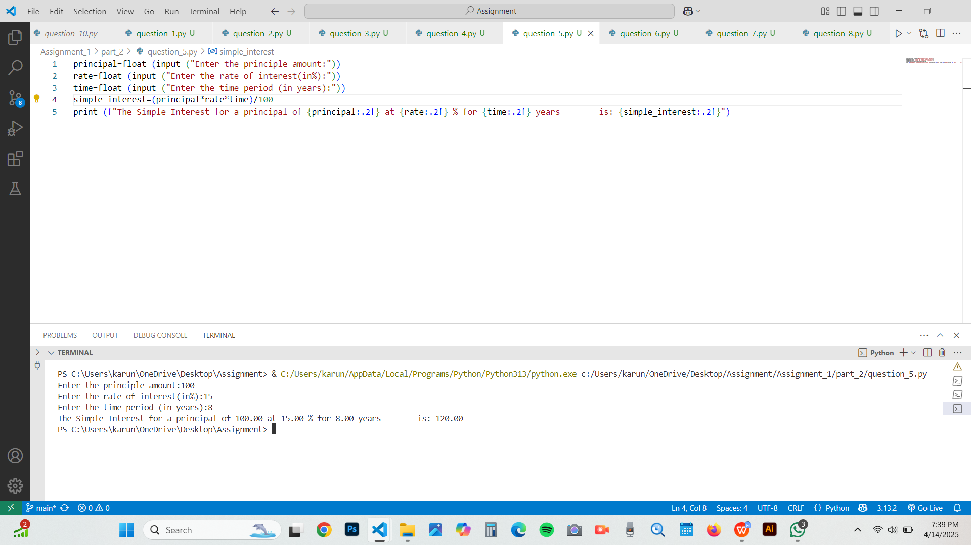

Q6. Write a Python program to find those numbers which are divisible by 7 and multiple of 5, between 1500 and 2000 (both included).
Code:
'''This program shows the number between 1500 and 2000 divisible by 7 and multiple of 5'''
for num in range (1500,2001):
if num%7==0 and num%5==0: #Check divisibility by 7 and 5
print (num, end=",")
Output:
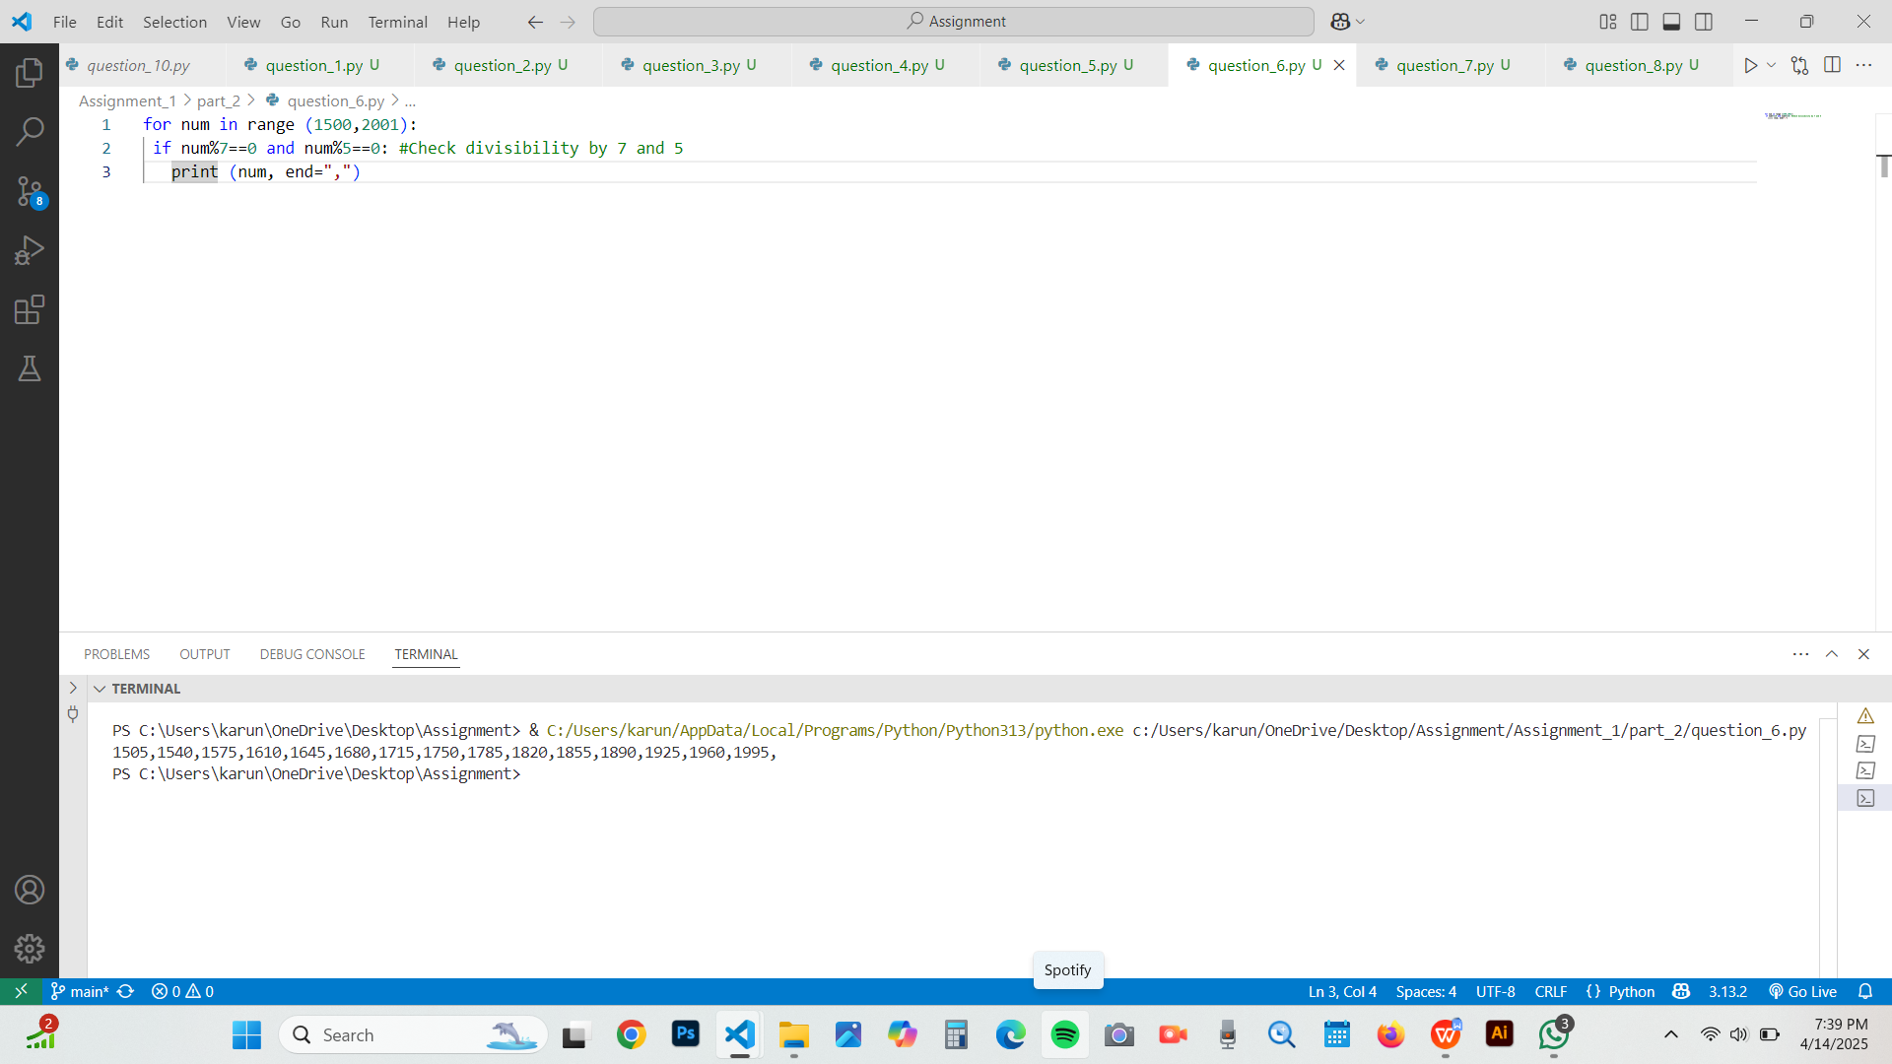

Q7. Write a Python program that accepts a string and calculates the number of digits and letters.
Code:
'''This program calculates the number of letter and digits in the given string'''
user _input=input ("Enter a string:")
#Initializing counters
letter_ count=0
digit_ count=0
for char in user_ input:
if char. Isalpha (): #check if the character is letter
letter_ count+=1
elif char. isdigit (): #check if the character is digit
digit_ count+=1
print (f "Number of letters: {letter_ count}")
print (f "Number of digits: {digit_ count}")
Output:
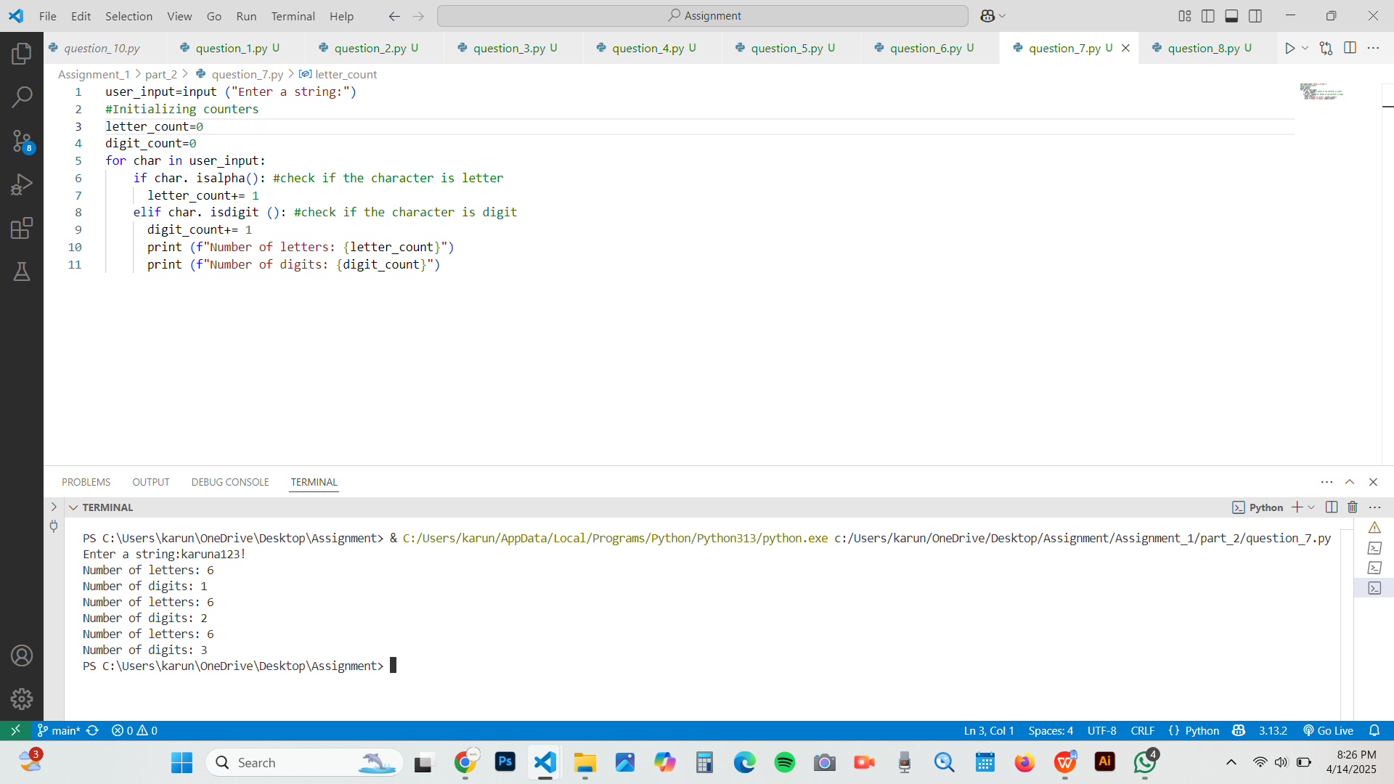

Q8. Write a program to create a number guessing game for the user. The program should ask the user to input a number. The program specifications are as mentioned below.
- The program should generate a random number for the answer.
- The program should prompt the user for a number input.
- The program should provide the feedback to the user after each guesses (e.g. “Too high”, “Too low” or “Correct number”).
- The program should check the user input for 5 times and allow the users to guess for at most 5 times if their input don’t match the answer number.
If the user is not able to guess the answer within 5 times, the program should display “Game Over” message and exit.
Code:
'''This program creates a number guessing game for the user'''
import random
# Generate a random number between 1 and 100
answer = random. randint (1, 100)
print ("Welcome to the Number Guessing Game!")
print ("You have 5 attempts to guess the correct number between 1 and 100.")
# Allow the user to guess up to 5 times
attempts = 5
for i in range(attempts):
# Prompt the user for a number input
guess = int (input (f "Attempt {i+1}: Enter your guess: "))
# Check if the guess is correct, too high, or too low
if guess == answer:
print (" Congratulations! You guessed the correct number!")
break # Exit the loop since the correct number is guessed
elif guess < answer:
print ("Too low! Try again.")
else:
print ("Too high! Try again.")

# If it's the last attempt and the user hasn't guessed correctly
if i == attempts - 1:
print (f "Game Over! The correct number was {answer}.")
Output:
